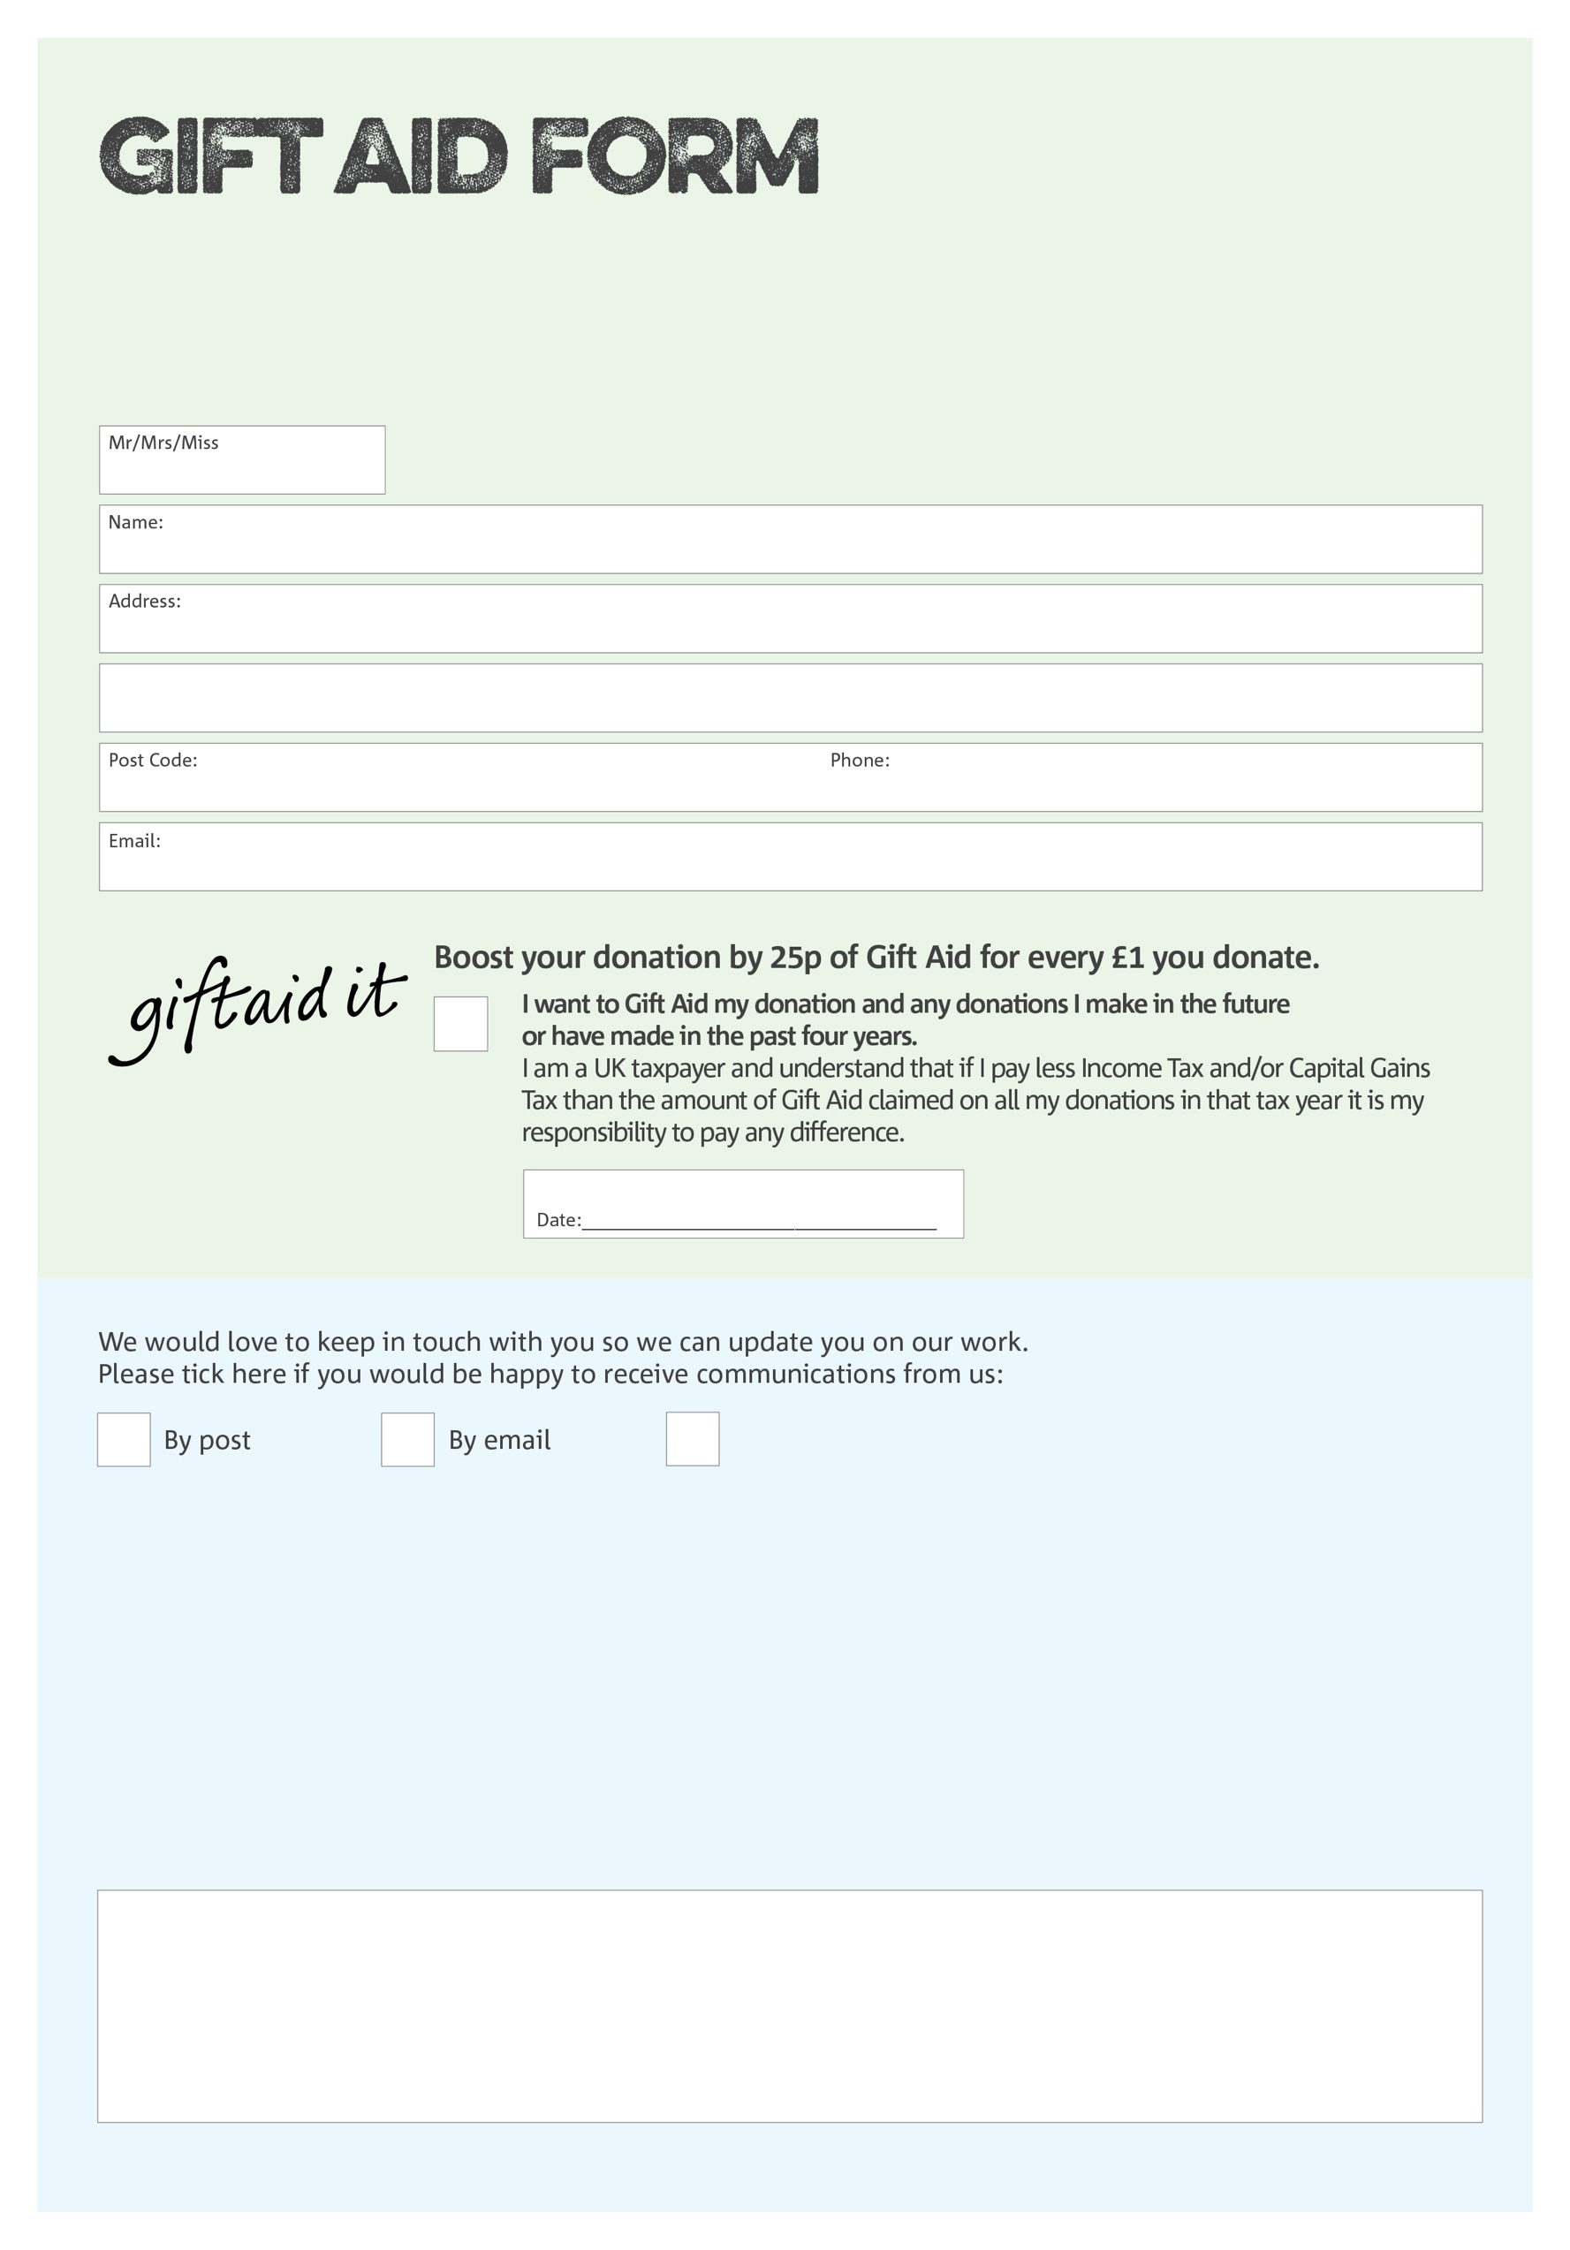
By filling in this form Deal Area Foodbank will receive an extra 25p for every £1 you give at no extra cost to you. Thank you!
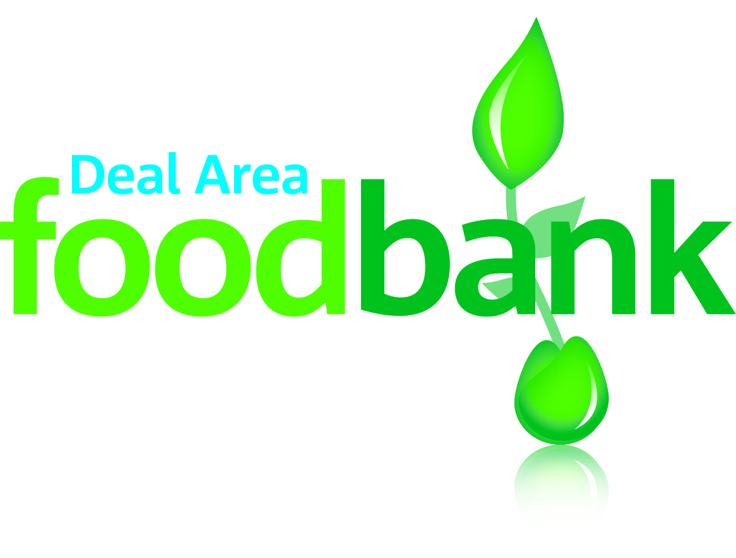

Data protection

'Deal Area Foodbank is committed to protecting your privacy and will process your personal data in accordance with current Data Protection legislation. Deal Area Foodbank collects information to keep in touch with you and supply you with information relating to our work. To unsubscribe from our newsletter, send a message to the email address above with the word unsubscribe in the subject line. A full data privacy statement for financial donors is available from the foodbank on request.’

Charity Number 1158590. Registered in 2015
We would love to know why you have chosen to donate to Deal Area Foodbank. If you would like to share your motivation let us know below:
You can change your preferences any time by contacting us on 01304 758428 or emailing us at
info@dealarea.foodbank.org.uk

I do not wish to receive future communications from
Deal Area Foodbank

