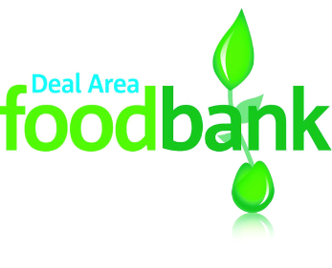
Shopping list
We are particularly short of
✱ Tinned veg ✱ Tinned fruit ✱ Custard
✱ Instant mash ✱ Cuppa soup ✱ Shampoo
✱ Instant desserts ✱ Rice pudding
We are also looking for
✔ Cold tinned meat ✔ Tinned fish ✔ Rice
✔ Tinned potatoes ✔ Tinned tomatoes ✔ Ketchup
✔ Household cleaning ✔ UHT milk ✔ Squash

Collection bins at
Deal: Sainsbury’s, Town Hall, Community Church, Trinity Church, St Thomas’s Church, Tesco Mill Hill, Coop Mill Hill, Golf Road Centre
Wider area: Tesco Westwood Cross, Coop Sandwich, Coop Aylesham, St Finnbarr’s Church Aylesham , St Clement’s Church Sandwich
And at many other churches, schools, shops and charities

Thank you so much for your support which enables us to help people in food crisis in the Deal Area.
Deal Area Emergency Foodbank, registered as a charity in England and Wales no 1158590, www.dealarea.foodbank.org.uk

