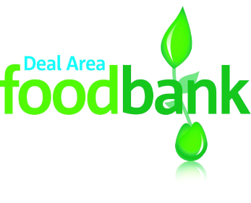
DONATE HERE
We are particularly short of
✱ Tinned veg ✱ Tinned fruit ✱ Rice pudding ✱ Custard
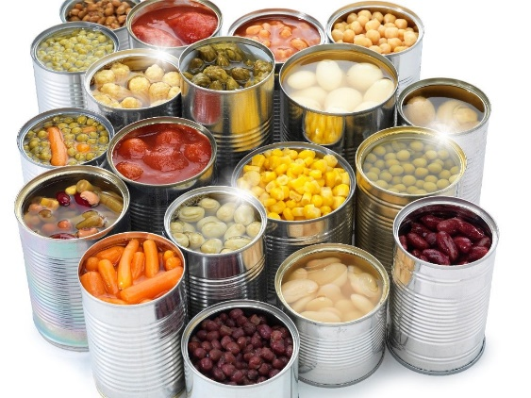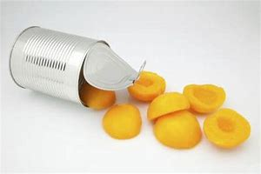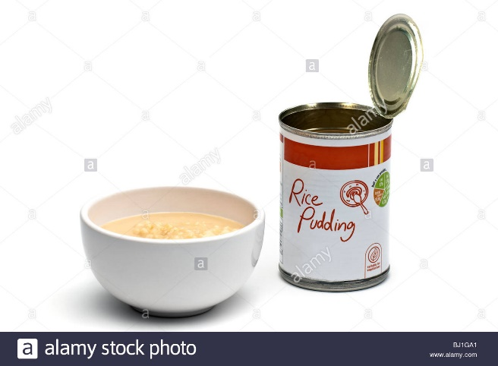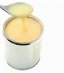
✱ Instant mash ✱ Cuppa soup ✱ Instant desserts ✱ Shampoo
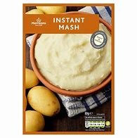 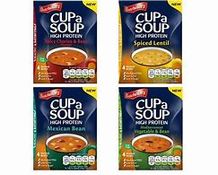 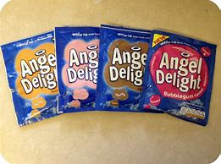
Thank you so much for your support which enables us to help people in food crisis in the Deal Area.
Deal Area Emergency Foodbank, registered as a charity in England and Wales no 1158590, www.dealarea.foodbank.org.uk

