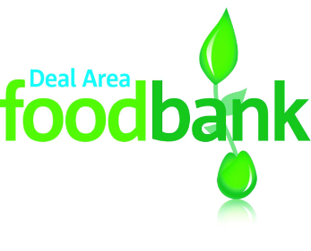
Shopping list
We are particularly short of
✱ Tinned veg ✱ Tinned fruit ✱ Custard
✱ Instant mash ✱ Cuppa soup ✱ Shampoo
✱ Instant desserts ✱ Rice pudding
We are also looking for
✔ Cold tinned meat ✔ Tinned fish ✔ Rice
✔ Tinned potatoes ✔ Tinned tomatoes ✔ Ketchup
✔ Household cleaning ✔ UHT milk ✔ Squash

Thank you so much for your support which enables us to help people in food crisis in the Deal Area.
DONATE HERE
Deal Area Emergency Foodbank, registered as a charity in England and Wales no 1158590, www.dealarea.foodbank.org.uk

